

**Overview**

**Prepared By:** AI Business Analyst   
 **Report Period:** Last 30 Days   
 **Report Type:** Comprehensive Business Intelligence & Insights

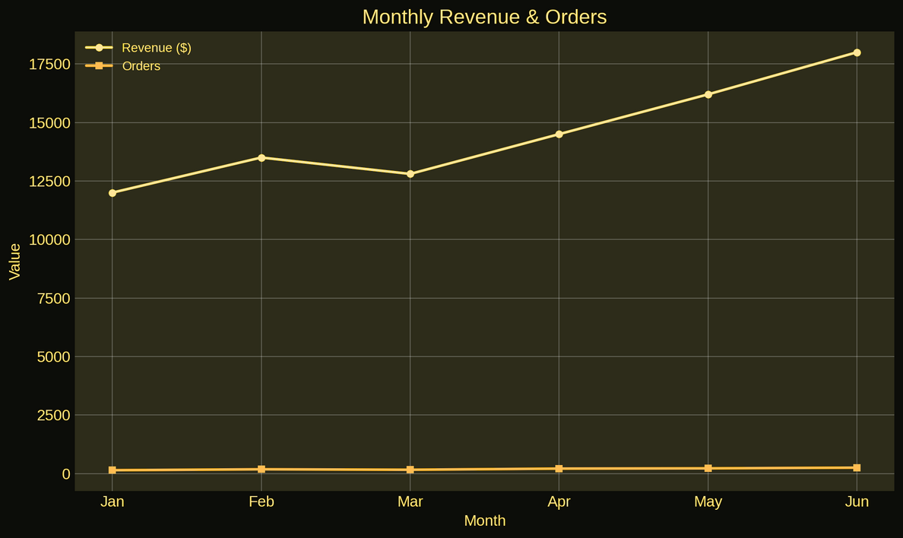

**Executive Summary**

Over the past 30 days, business performance has shown significant improvements:

* **Revenue:** $81,276 (↑ 18%)
* **Orders:** 936 (↑ 12%)
* **Avg Order Value:** $86.83
* **Market Share:** 12.8% (↑ 2.1%)

Overall: Positive growth across all KPIs, strong customer satisfaction, and emerging market opportunities identified.

**Sales Performance**

*Top Products by Revenue:*

* **Wireless Headphones:** $45,234 (32% margin)
* **Smart Watches:** $34,567 (42% margin)
* **Bluetooth Speakers:** $28,900 (28% margin)

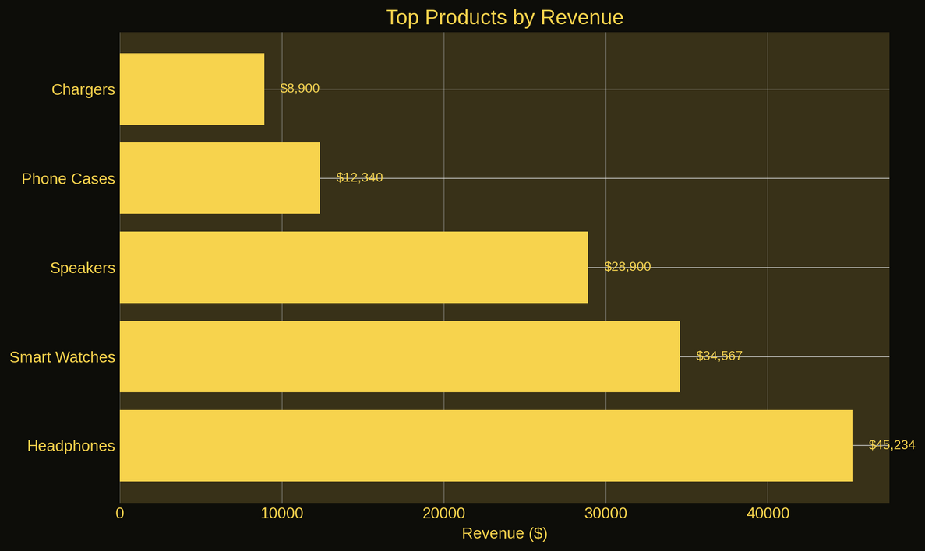

*Monthly Trend:*

* Sales steadily grew with **June 2024** being the best-performing month.
* **Avg Growth Rate:** +12.5% month-over-month
* **Top Category:** Audio (67% of total revenue)

**Marketing Overview**

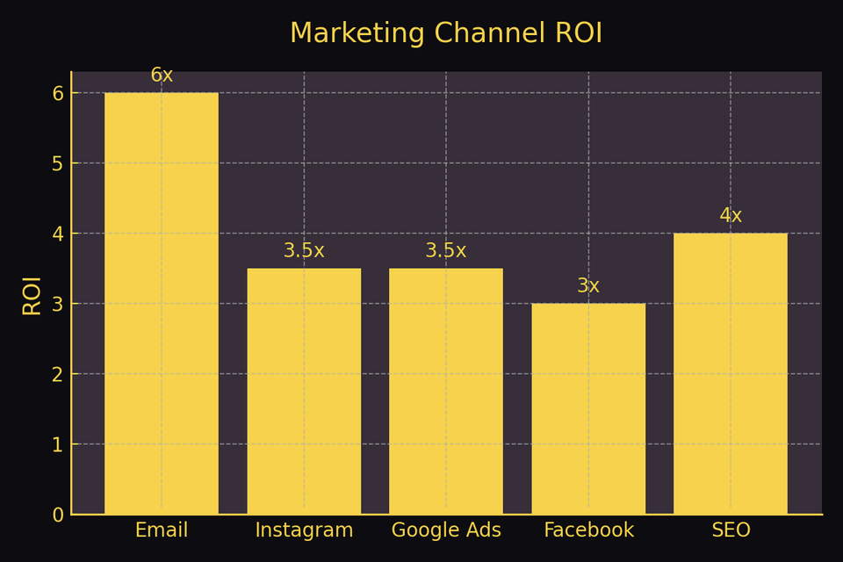

*Insight:*

* **Instagram** delivers high ROI and is ideal for further scaling.
* **Email** remains the most efficient, low-cost conversion channel.

**Competitive Landscape**

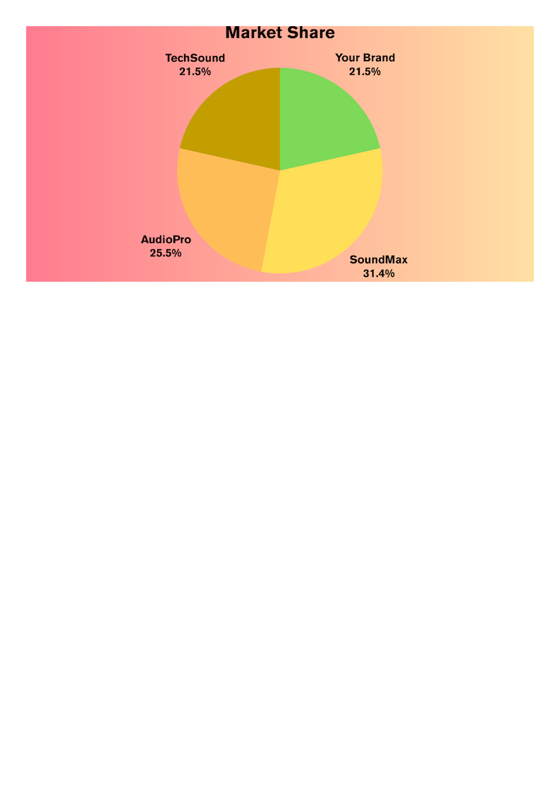

Your brand maintains competitive pricing with growth potential in brand strength.

**Operations Summary**

* **Order Fulfillment Rate:** 98.5%
* **Avg Delivery Time:** 2.3 hours (↓ 15%)
* **Return Rate:** 2.1% (industry avg: 3.2%)
* **Customer Satisfaction:** 4.2 / 5 (1,247 reviews)

Operations are efficient, customer-centric, and outperform industry benchmarks.

**Insights & Recommendations**

*Key Opportunities:*

* Restock **wireless headphones** — demand ↑ 340%
* Expand **Instagram marketing**
* Target **ages 25–34** — 67% higher conversion
* Launch premium product line at **$150–$200**

*Strategic Actions:*

* Deploy **dynamic pricing** (+12% revenue)
* Strengthen delivery in **Manhattan**
* Build a **customer loyalty program**
* Scale **content marketing** (engagement 7.3% vs 4.2%)

*Risks:*

* **Tech Sound price cuts** may shift market share
* **Supply chain reliance** on 3 vendors
* **Rising CAC** (+15%)
* **Seasonal demand** needs optimization

**Contact Information**

*For any questions or clarifications, please reach out to us :   
+91-12345-67890   
pminsights123@gmail.com*

***AI Business Analyst*** *— Unlocking retail intelligence with real-time dashboards, smart recommendations, and performance insights.   
Visit:* [*www.aibusinessanalyst.com*](https://ai-business-analyst.vercel.app)